Assignment – 1 •

**Install Power BI Desktop and share the final screenshot of the report view page which appears when power desktop starts.**

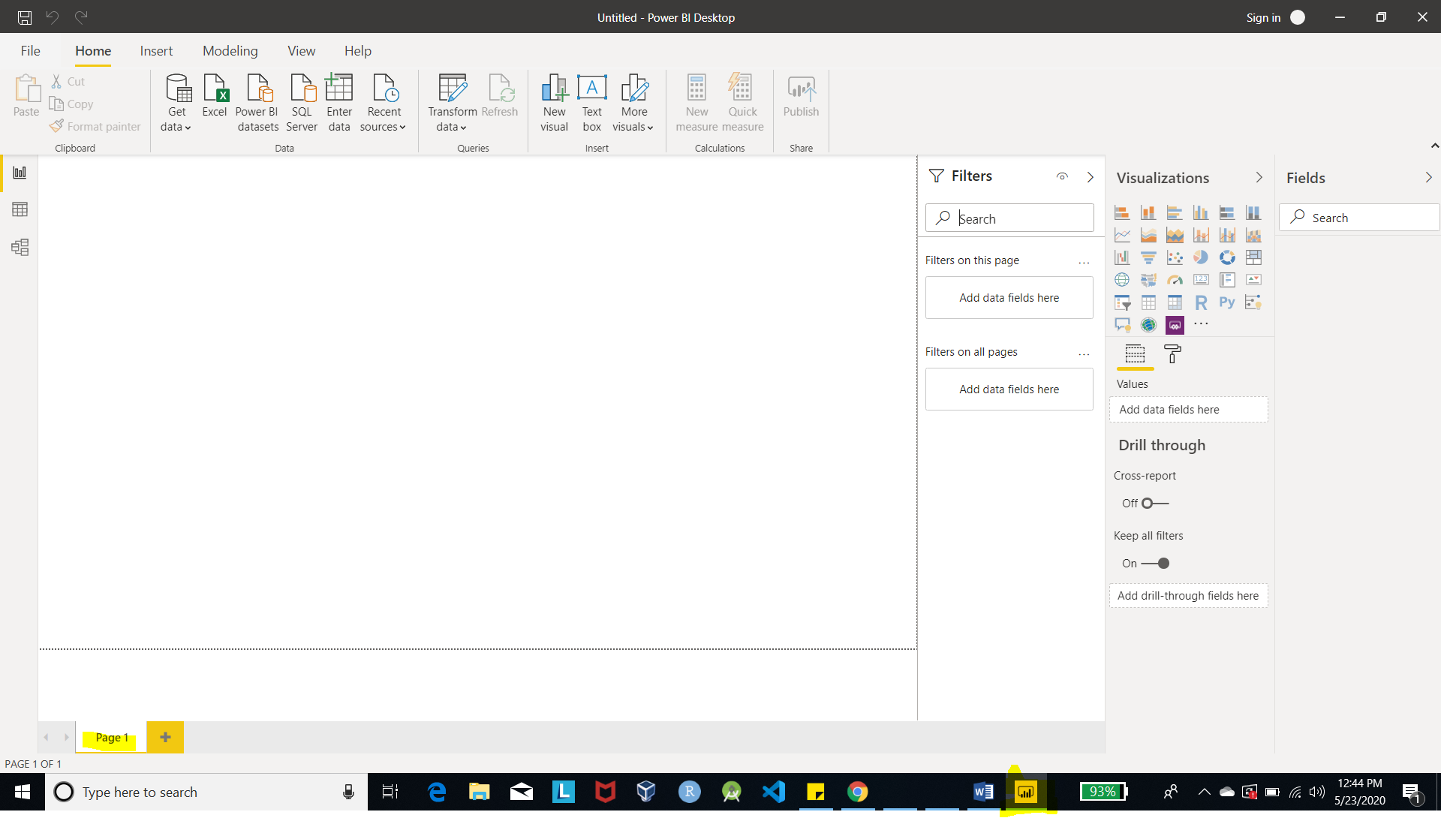

**Prepare a document and with the following screenshot**

**– Report View**

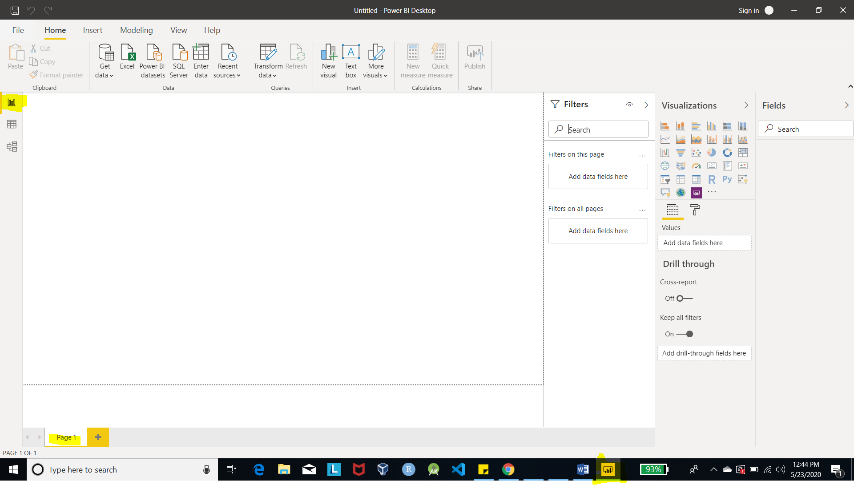

**− Data View**

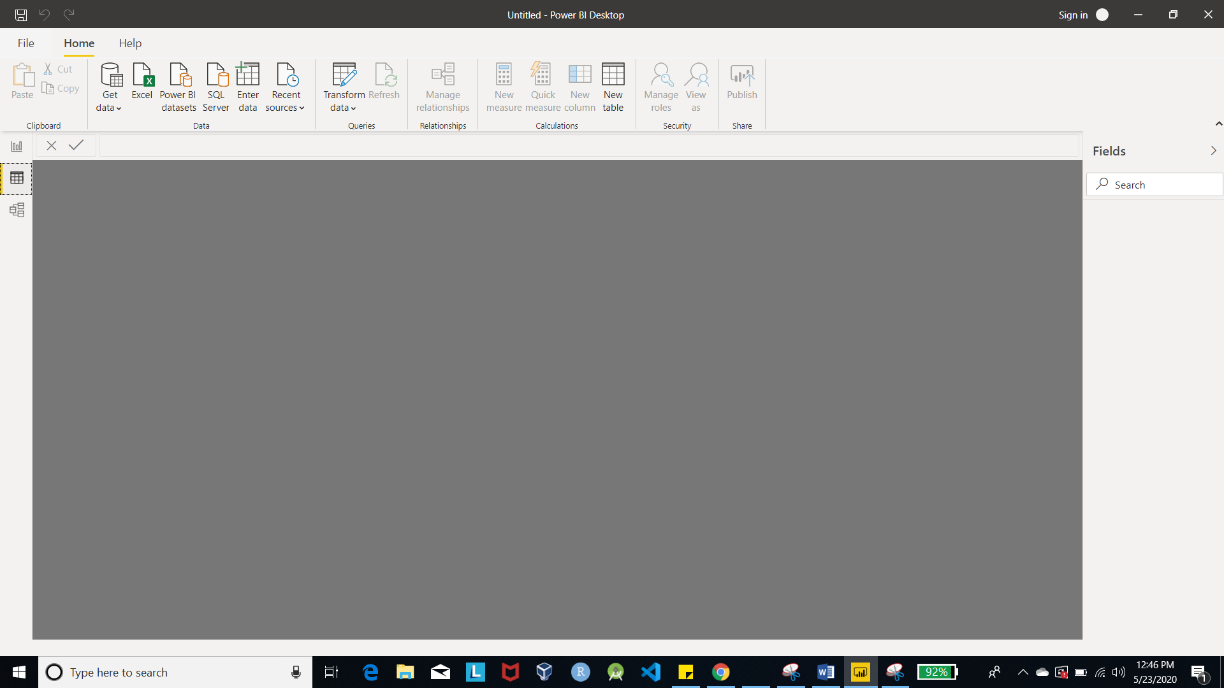

**− Model View**

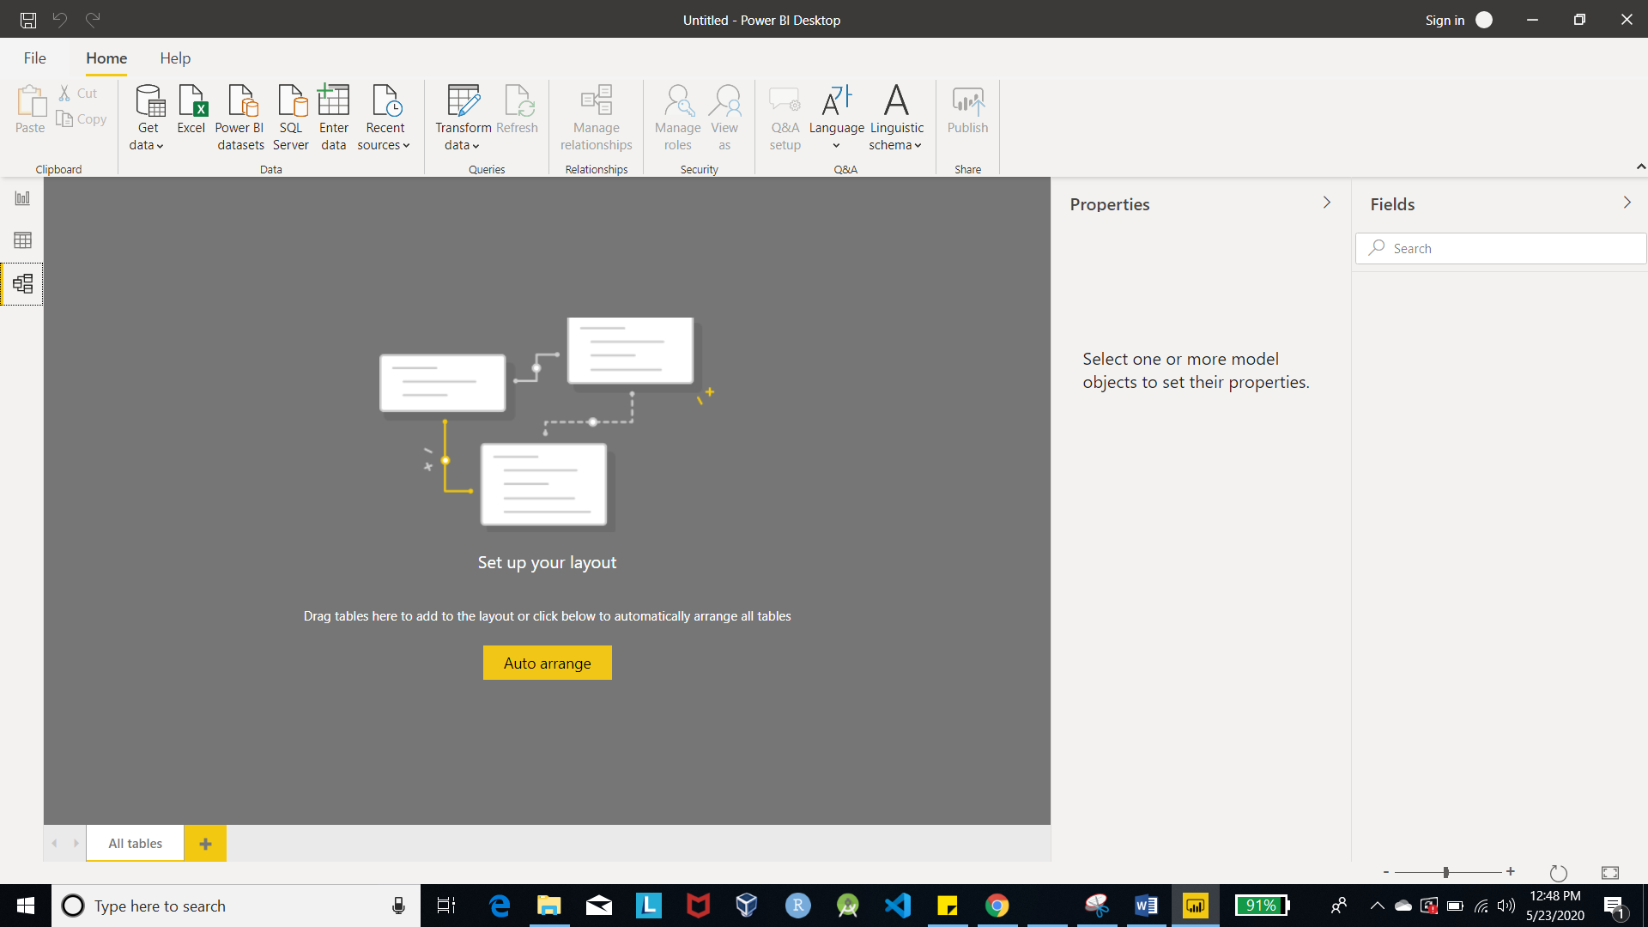

**− Power Query Editor**

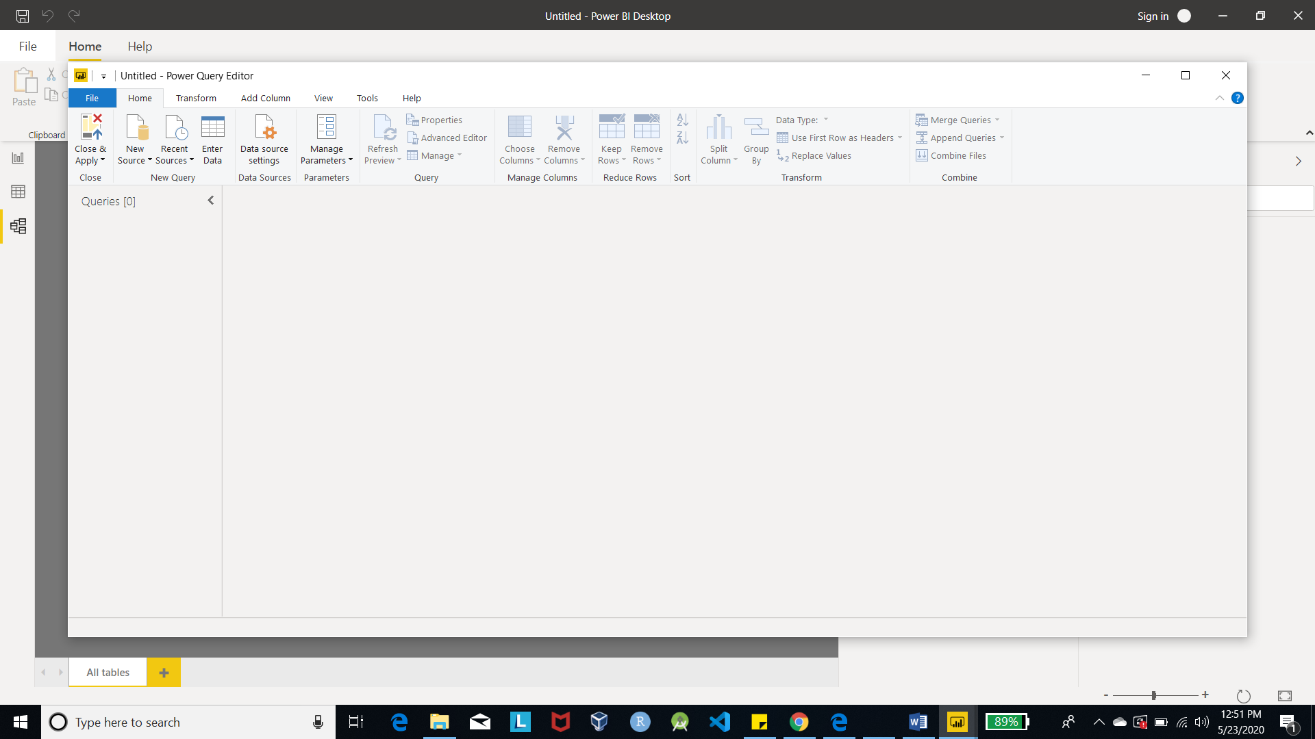

**− Advance Editor** 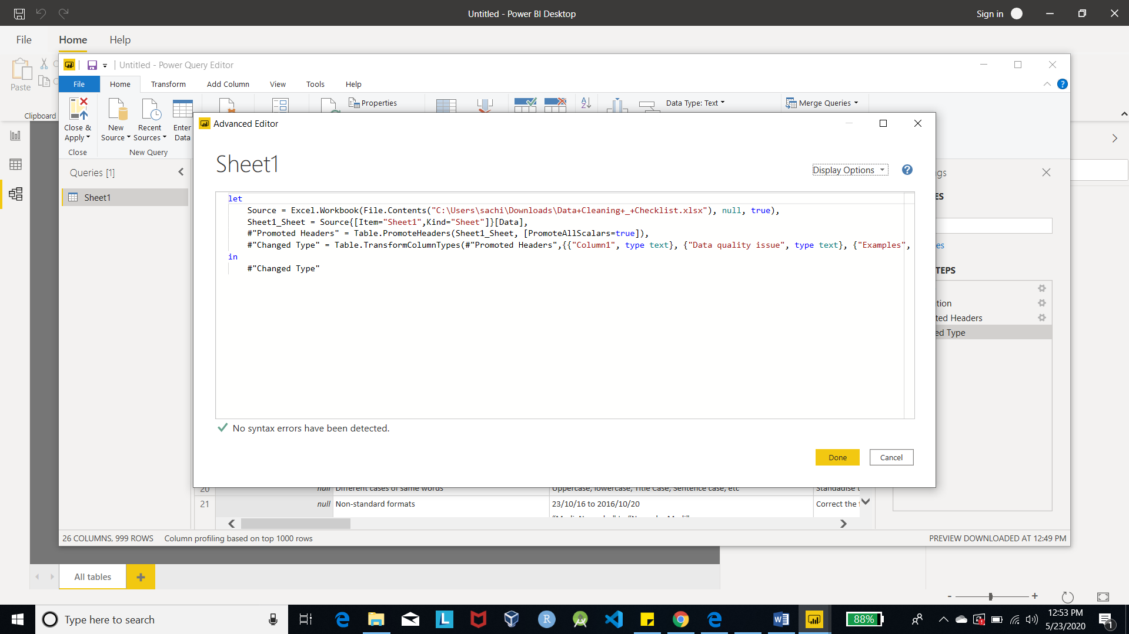

**Prepare a document with details of the following along with their price**

**− Power BI Desktop**

**− Power BI Pro**

**− Power BI Premium**

Microsoft Power BI Pricing: Licensing and Ownership Costs

Microsoft Power BI is a cloud-based business intelligence and analytics service that provides a full overview of your most critical data. Connecting to all of your data sources, Power BI simplifies data evaluation and sharing with scalable dashboards, interactive reports, embedded visuals, and more.

Power BI has three pricing plans:

* **Power BI Desktop:** This offering is free to any single user and includes data cleaning and preparation, custom visualizations, and the ability to publish to the Power BI service.
* **Power BI Pro:** The Pro plan costs $9.99/user/month. It includes data collaboration, data governance, building dashboards with a 360-degree real-time view, and the ability to publish reports anywhere. Users can try it a free trial for 60 days before purchasing the subscription.
* **Power BI Premium:** The Premium plan starts at $4,995 a month per dedicated cloud compute and storage resource.

